**Shrimp Stir-Fry Recipe**

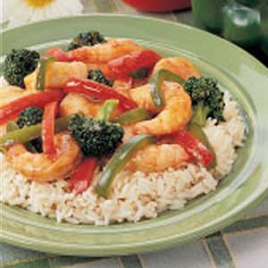Photo by: Taste of Home Shrimp Stir-Fry Recipe

* 3-4 Servings
* Prep/Total Time: 25 min.

**Ingredients**

* 1-1/2 cups *broccoli florets*
* *1 small sweet red pepper, juliened*
* *1 small green pepper, julienned*
* 1 to 2 tablespoons *vegetable oil*
* 1 pound *uncooked shrimp, peeled and deveined*
* 1 tablespoon *cornstarch*
* 2 teaspoons *brown sugar*
* 1 teaspoon *ground ginger*
* 1 cup *orange juice*
* 1/4 cup *soy sauce*
* *Hot cooked rice*

**Directions**

* In a skillet, stir-fry broccoli and peppers in oil until tender. Add shrimp; stir-fry for 3-5 minutes or until shrimp turn pink.
* Combine the cornstarch, brown sugar, ginger, orange juice and soy sauce until smooth; add to skillet. bring to a boil; cook and stir for 2 minutes or until thickened. Serve over rice.**Yield:**3-4 servings.

**Nutrition Facts:** 1 serving (1 cup) equals 188 calories, 5 g fat (1 g saturated fat), 168 mg cholesterol, 1,122 mg sodium, 15 g carbohydrate, 2 g fiber, 21 g protein.